REX Accounts
User Manual
Simple double-entry bookkeeping for New Zealand and Australia
Energy Conscious Design Limited

1. Introduction
REX Accounts is a full double-entry bookkeeping application for New Zealand and Australian small businesses. It runs entirely on your own computer — your financial data is stored in a single local file and never leaves your machine unless you choose to email or export it.
This manual covers every screen in REX Accounts, in the order they appear in the left-hand navigation menu.
This edition of the manual (27 September 2026) reflects the latest build, which adds editing and deleting of draft documents, GST handling for bank-coded transactions and expense claims, and a number of corrections found in testing.
- Invoicing, quoting and bills (accounts receivable and payable)
- Recurring invoices and automatic payment reminders
- Purchase orders, expense claims, and inventory tracking
- Multiple bank accounts, CSV/QIF import, and reconciliation
- Standard financial reports (Profit & Loss, Balance Sheet, GST101A, and more)
- A visual Dashboard with clickable monthly charts

2. Getting Started

2.1 Activating your licence
The first time you open REX Accounts, you will be asked to enter your company name and licence key exactly as supplied when you purchased the product. REX Accounts checks the key against your company name — both must match what was issued.
REX Accounts runs entirely on your own machine, so nothing about your business data is sent anywhere as part of activation.
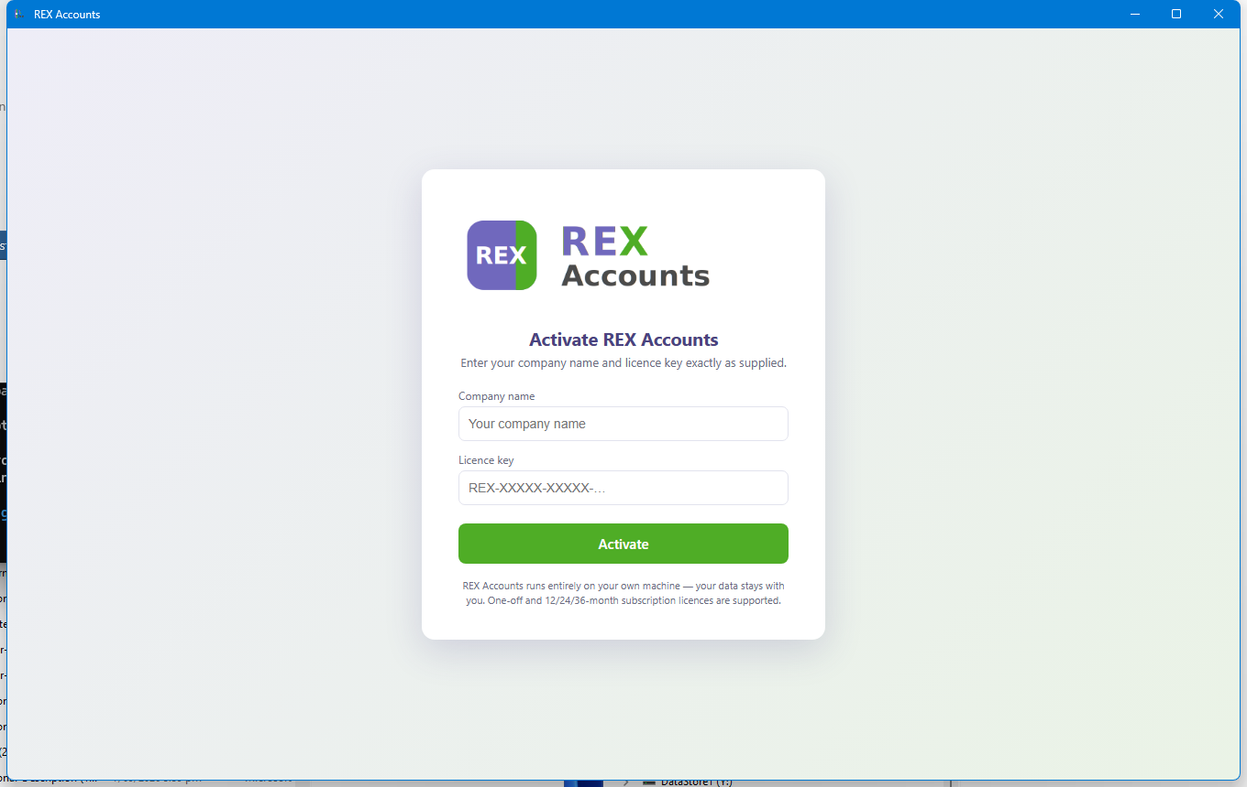
The licence activation screen.

2.2 Creating your admin account
After activation, the very first user you create becomes the administrator. Enter your name, choose a username, and set a password. Additional staff accounts can be added later from Settings by an administrator.
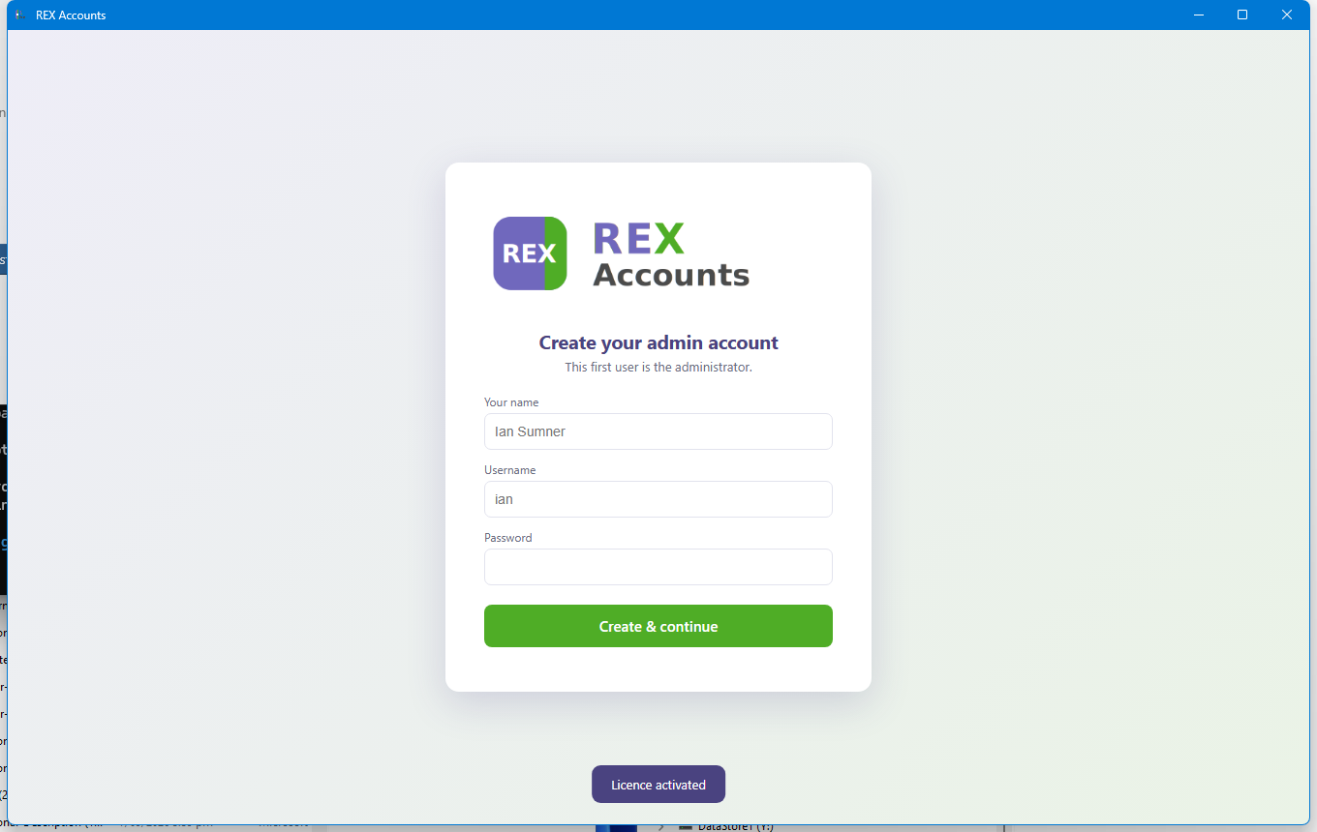
Creating the first (admin) user account.

2.3 Signing in
On every subsequent launch, REX Accounts asks for a username and password. If two-factor authentication (MFA) has been turned on for a user, a six-digit code from an authenticator app is also required.
Forgotten username or password. Click "Forgot your username or password?" on the sign-in screen, enter the company name and licence key from your purchase email, and REX Accounts lists the usernames on this computer and lets you set a new password for any of them (with the option to switch off two-factor authentication for that user). Everything happens on your computer; nothing is sent anywhere.
Changing passwords. Settings › My account shows your username and has a "Change my password" button (your current password is required). Administrators also see a "Reset password" button beside each user under Users & access.

3. Dashboard
The Dashboard is the home screen and gives an at-a-glance view of the business. Across the top are quick tiles for each bank account balance, total owed to you by customers, and total you owe to suppliers.
Below the tiles is a grid of charts, each showing the current financial year month by month:
- Invoices per month — click any bar to see that month’s invoices.
- Bills to pay per month — click any bar to see that month’s bills.
- Cash in / out per month — green bars for money in, red for money out.
- Cash in / out — financial year to date — the same two figures accumulated across the year, plus the running net difference.
- Net profit / loss per month — green for a profitable month, red for a loss, with a dashed line overlay showing the running total for the year.
- Net profit — financial year to date — the cumulative year-to-date profit position as its own chart.
At the bottom of the Dashboard is a table of the most recent invoices for quick reference.
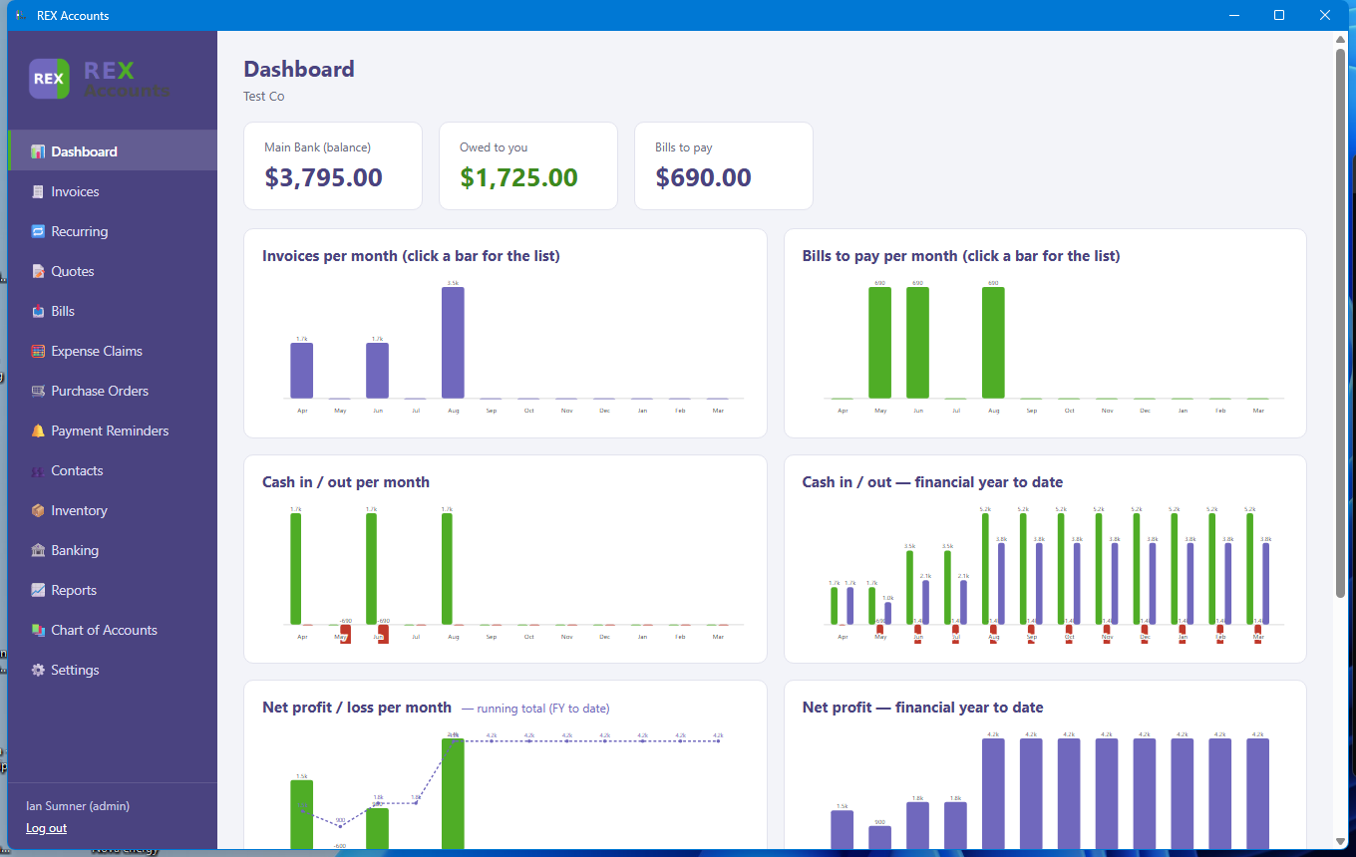
The Dashboard, showing tiles and the chart grid.

4. Invoices
The Invoices screen lists every invoice you have raised, with its number, customer, dates, total, and status (draft, approved, partial, or paid). Use New Invoice to create one, Receive Payment to record money coming in against one or more invoices, and Email Invoices to send copies to customers directly from the app.
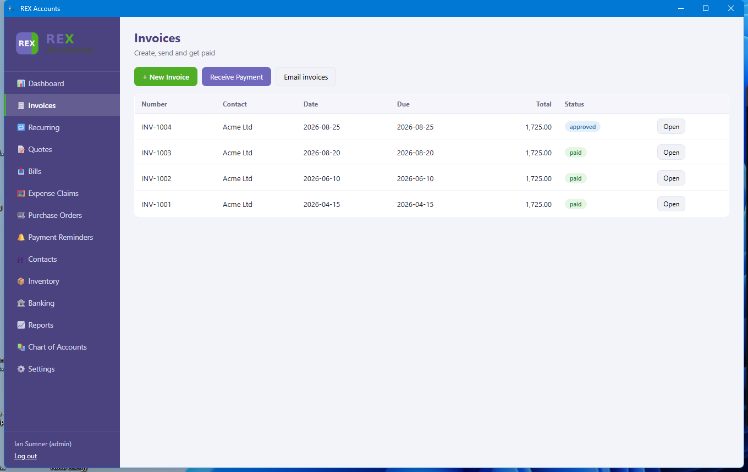
The Invoices list.
Click Open on any invoice to see its lines. While an invoice is still a draft you can also Edit it (change the contact, dates, lines or notes) or Delete it. Once approved it is posted to the ledger and can no longer be changed - only paid.
Receive Payment lists the approved invoices for the chosen customer. Tick an invoice to fill in the full amount owing, or type a smaller amount for a part payment. REX Accounts will not accept more than the outstanding balance - the dialog stays open and explains why.

5. Recurring Invoices
Recurring Invoices are templates that automatically generate a real invoice on a schedule (for example, a monthly retainer). Set the contact, frequency, and next date, and use “Generate due now” to create any invoices that have become due.
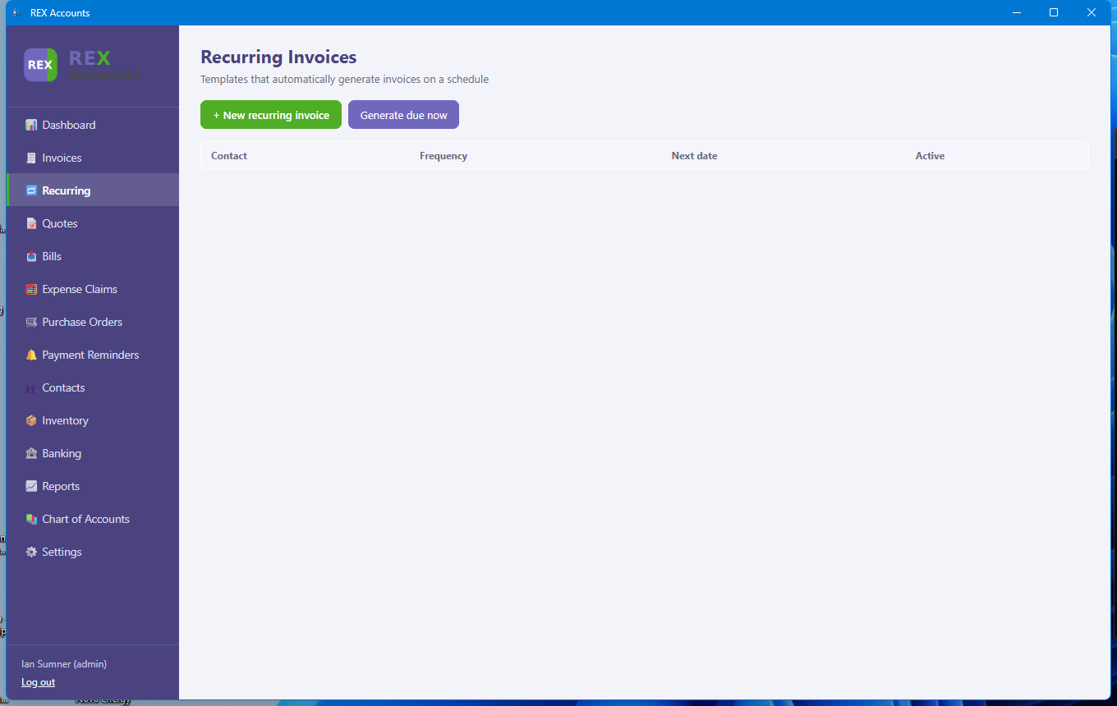
The Recurring Invoices screen (no templates set up yet).
Monthly, quarterly and yearly templates keep their intended day of the month: a template set for the 31st generates on the 28th of February and returns to the 31st in March. Each generated invoice is linked to its template.

6. Quotes
Quotes work like invoices but carry no accounting weight until accepted. Once a customer accepts a quote, approve it and convert it directly into an invoice — no need to re-enter the line items.
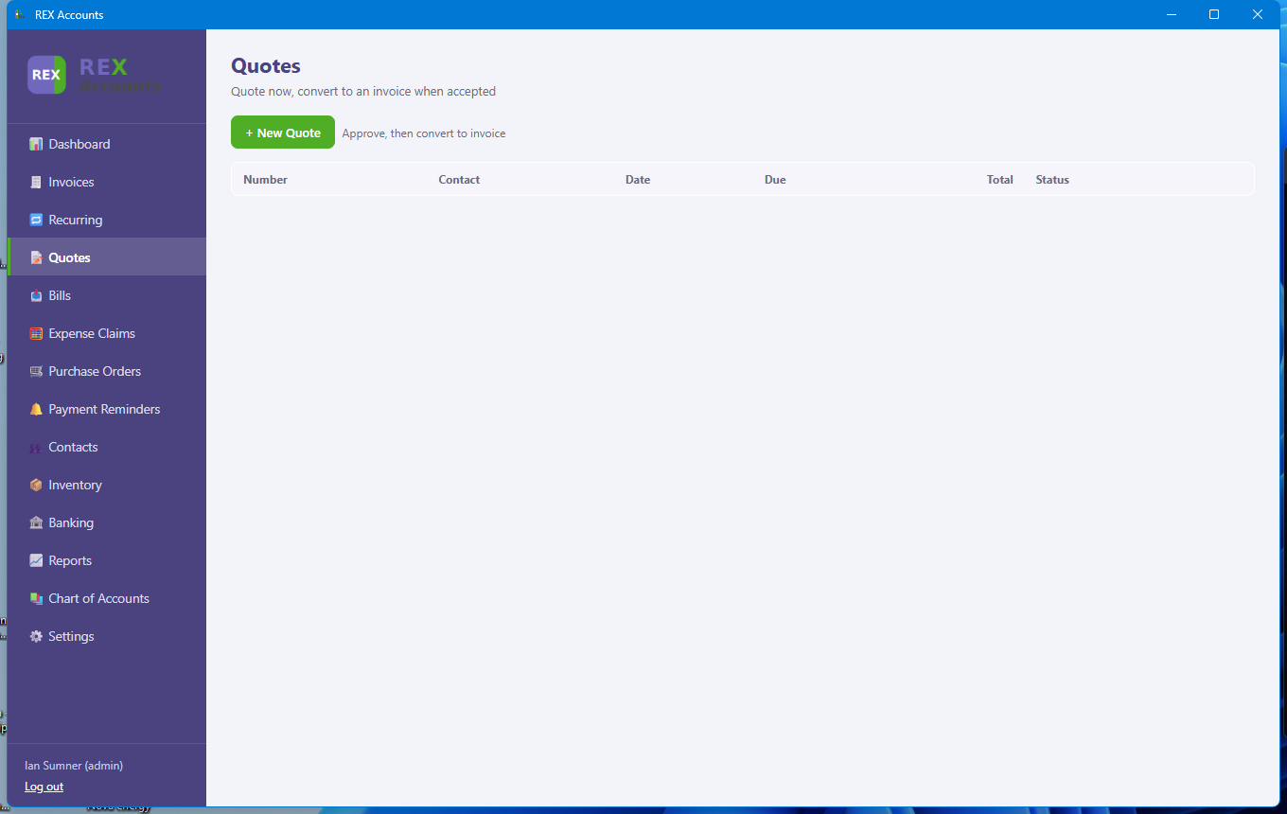
The Quotes screen.
Draft quotes can be edited or deleted from their Open view. Converting an accepted quote creates a new draft invoice with the same lines, ready to review and approve.

7. Bills
Bills are supplier invoices — your accounts payable. The list shows each bill’s number, supplier, dates, total, and status. Use New Bill to enter one and Make Payment to record money paid out against one or more bills.
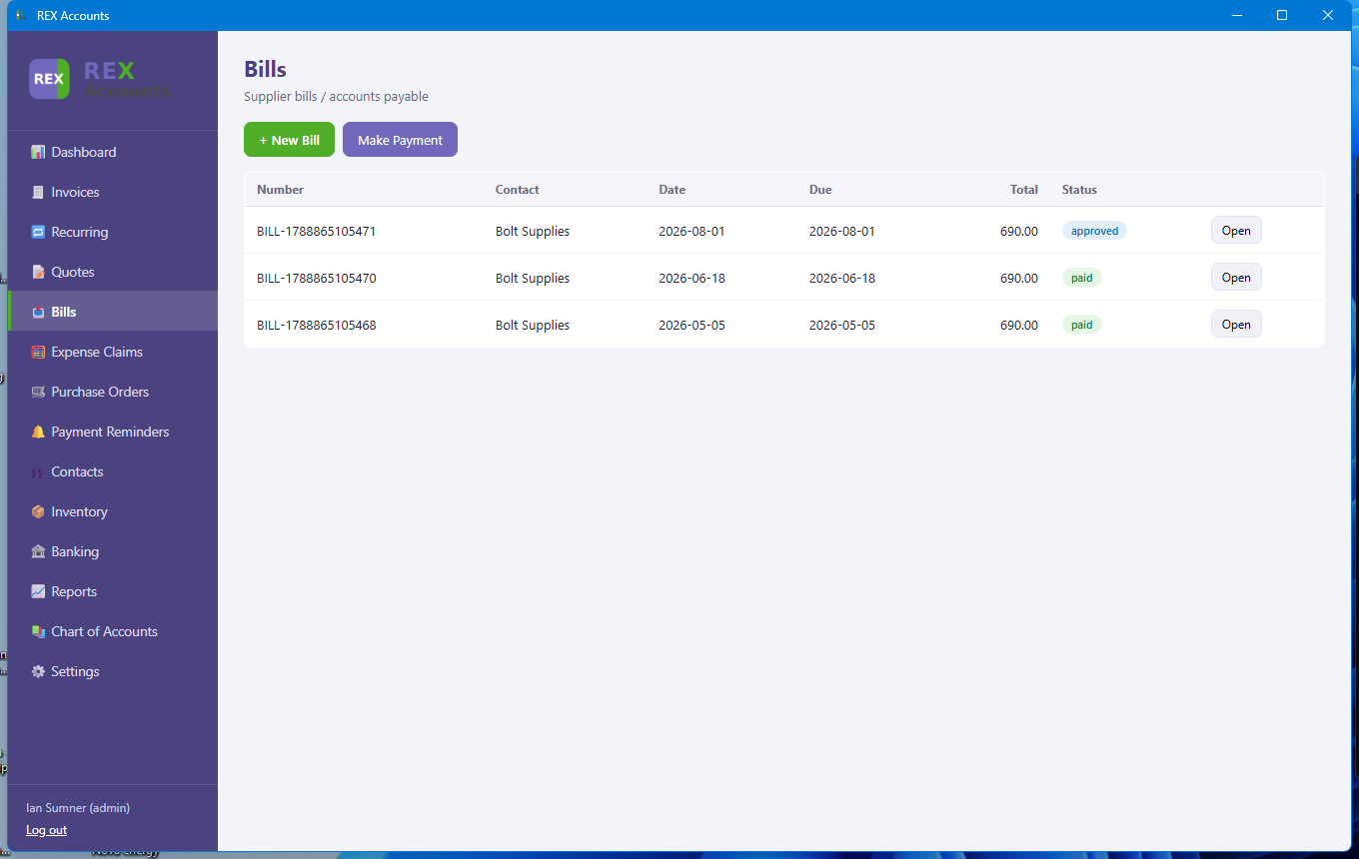
The Bills list, showing bills raised against Bolt Supplies.
If you leave the number blank, bills are numbered BILL-1, BILL-2 and so on; enter the supplier's own invoice number to use that instead. Draft bills can be edited or deleted from their Open view; Make Payment works like Receive Payment and will not accept more than is owing.

8. Expense Claims
Staff or owner out-of-pocket expenses are recorded here for reimbursement. Each claim tracks the claimant, date, total, and GST component, and moves through an approve-then-pay workflow just like a bill.
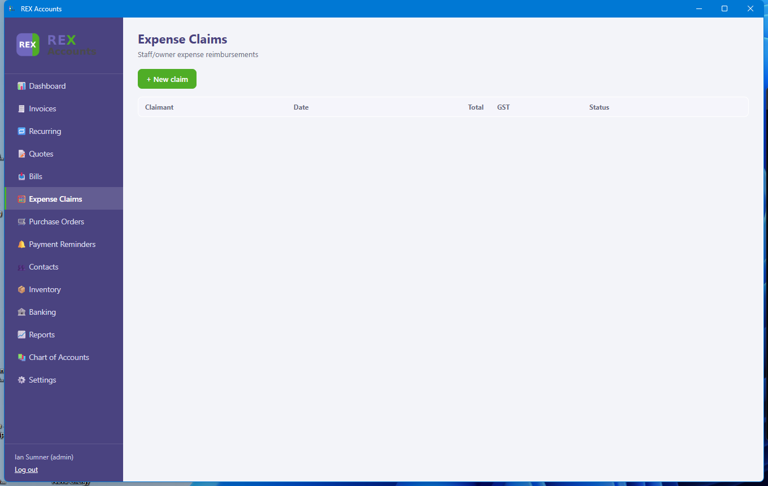
The Expense Claims screen.
Enter each line as the amount actually paid, including GST. REX Accounts works out the GST portion (3/23 in New Zealand, 1/11 in Australia) so the expense and the GST claim are posted correctly, and the claim appears in the GST return.

9. Purchase Orders
Purchase Orders record what has been ordered from a supplier before the goods or invoice arrive. Once approved, a purchase order converts directly into a bill on receipt, the same way a quote converts into an invoice.
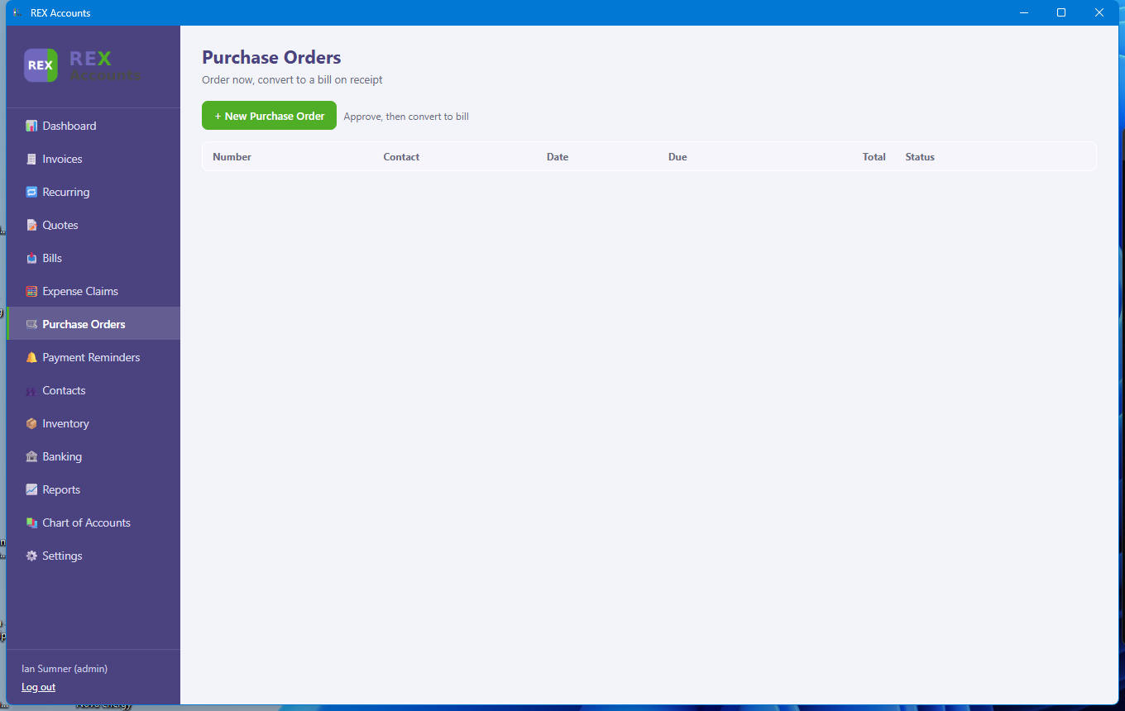
The Purchase Orders screen.
Draft purchase orders can be edited or deleted from their Open view.

10. Payment Reminders
This screen lists every overdue invoice, how many days overdue it is, and the amount still outstanding. Tick the ones to chase and click “Send reminders for ticked” to email a polite reminder to each customer in one action.
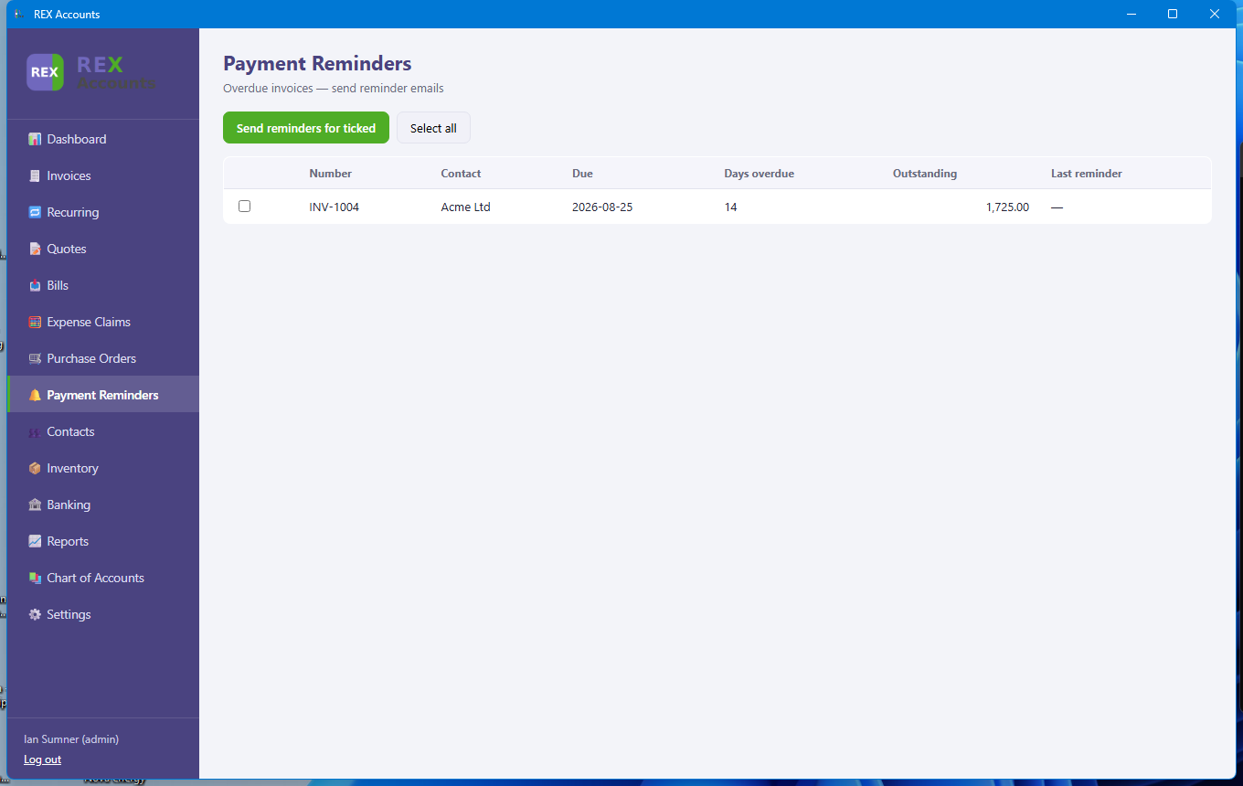
An overdue invoice ready for a reminder to be sent.

11. Contacts
All customers and suppliers are managed from one list. Each contact records name, type (customer or supplier), email, phone, and address. Customer contacts also have a Statement button to produce an account statement of their outstanding invoices.
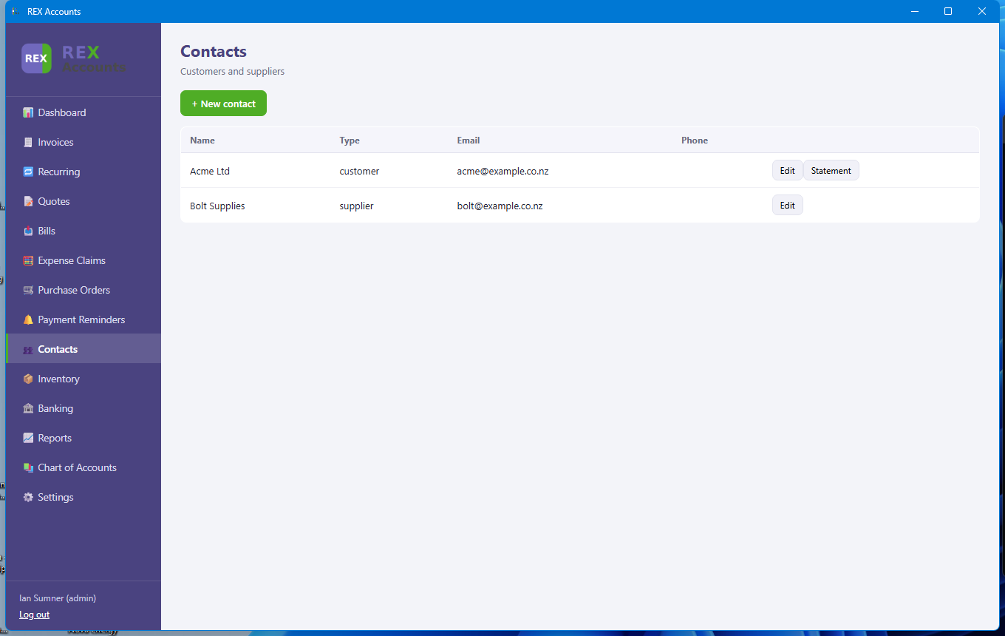
The Contacts list.

12. Inventory
Stock items can be tracked here with a SKU, unit cost, and sale price. Quantities on hand update automatically as items are added to invoices and bills, so stock levels stay accurate without manual adjustment.
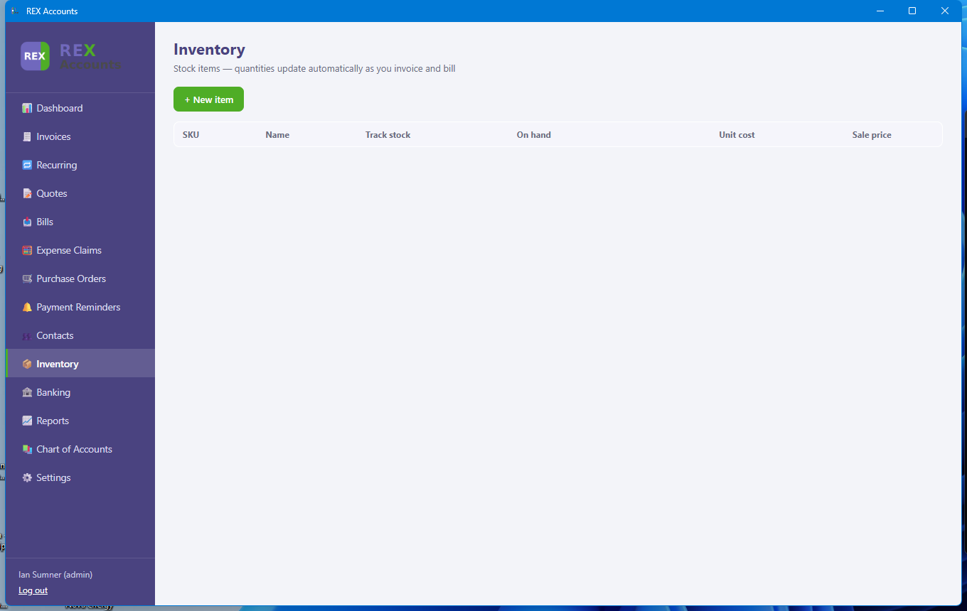
The Inventory screen (no items added yet).

13. Banking
REX Accounts supports multiple bank or cash accounts. Each account’s transaction list can be built up by importing a CSV or QIF file exported from your online banking, and each transaction can then be matched and reconciled against the ledger.
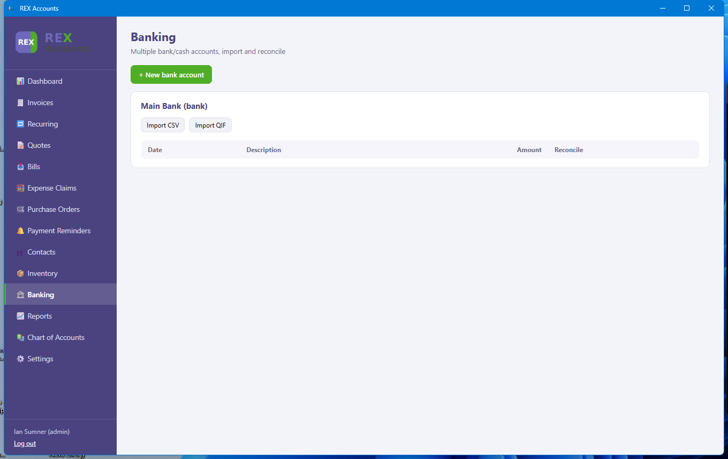
The Banking screen, showing the Main Bank account.
When you categorise an imported transaction to an income or expense account, the GST portion is split out automatically (for accounts marked taxable) so the GST return and Profit & Loss are right without any extra steps. Accounts marked exempt or zero-rated are posted without GST.

14. Reports
Seven standard financial reports are available: Profit & Loss, Balance Sheet, Trial Balance, Aged Receivables, Aged Payables, Cash Flow, and the New Zealand GST101A return. Each report can be run for any date range and reflects live ledger data.
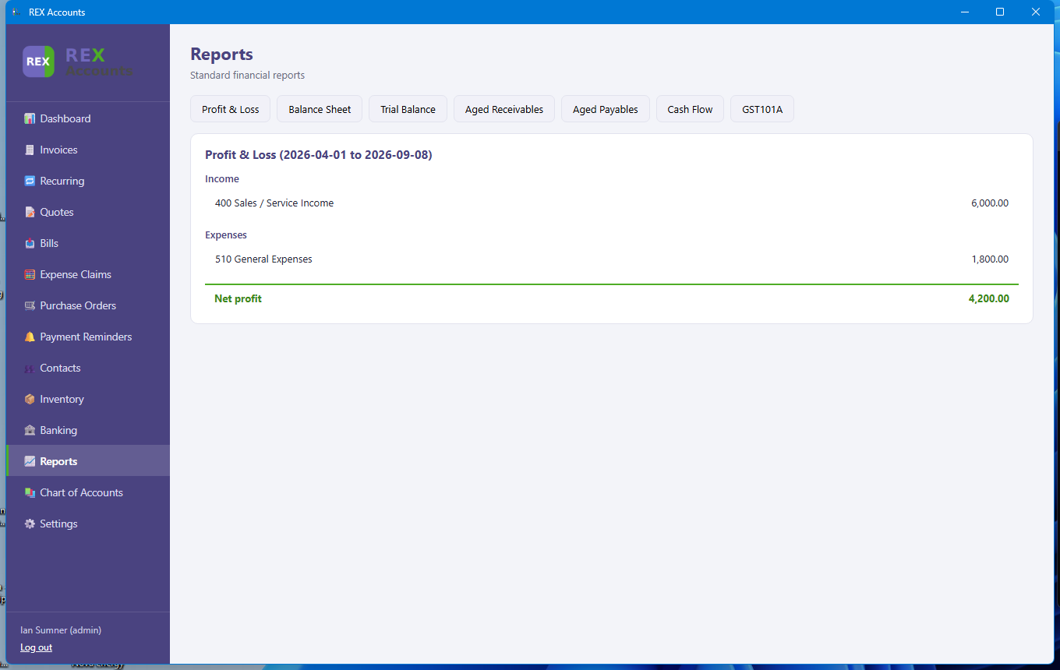
A Profit & Loss report for the current financial year to date.
The GST101A figures include invoices and bills, approved expense claims and bank transactions you have categorised, so the return reflects everything recorded in REX Accounts for the period. File the figures through myIR (or hand them to your accountant) - REX Accounts does not file electronically.

15. Chart of Accounts
The full list of general ledger accounts — assets, liabilities, equity, income, and expenses. System accounts (marked “Yes” under System) are used internally by REX Accounts and cannot be deleted, but additional expense, income, asset, or liability accounts can be added freely to suit the business.
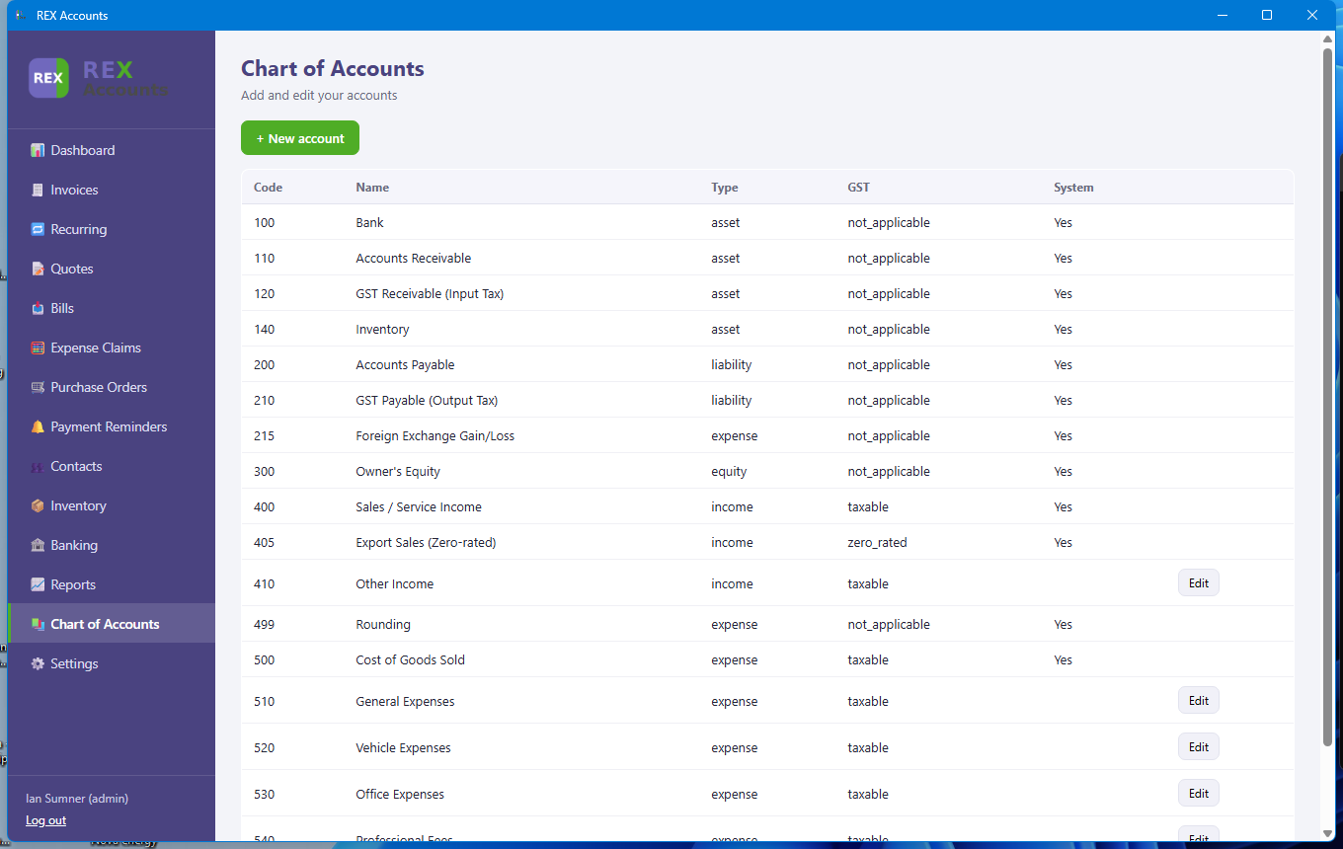
The Chart of Accounts.

16. Settings
Settings brings together everything needed to configure the company: company name and GST/IRD number, region and home currency, the financial year start month, invoice/statement branding, outgoing email (SMTP) for sending invoices and reminders, users and roles, and the licence.
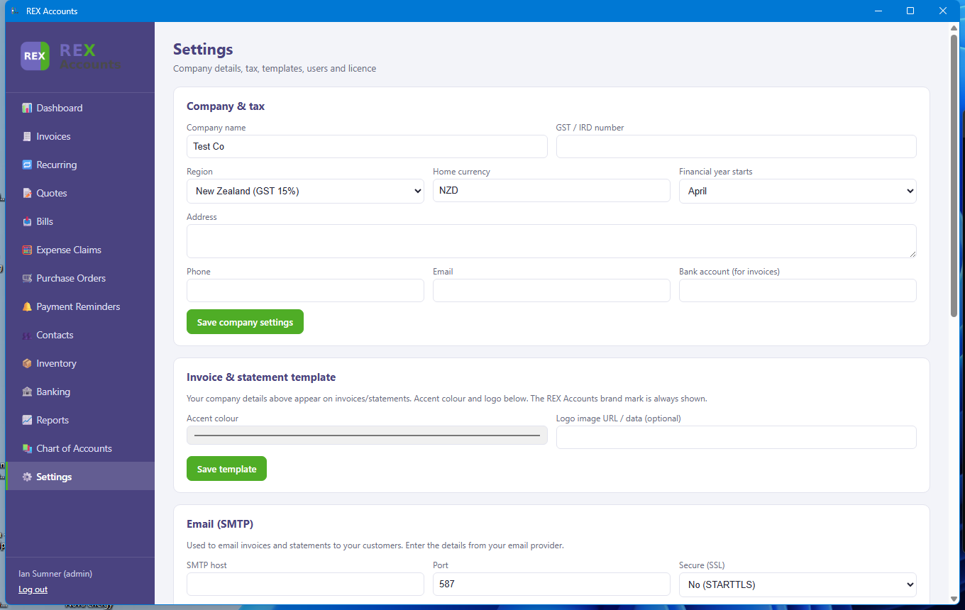
The top of the Settings screen — company and tax details.
You can change the company name shown on invoices at any time; your licence stays valid because it is tied to the name you activated with, which is kept separately.
If a save is refused (for example a duplicate account code or username) the dialog stays open and shows the reason.

