REX Paperworks
User Manual
View, mark up, and convert PDFs — entirely on your own machine
Energy Conscious Design Limited

1. Introduction
REX Paperworks is a full-featured PDF viewer and editor that runs as a standalone desktop program on your own computer — but 100% locally. No document is ever uploaded anywhere; the local program on your machine does all the work and serves the interface to your browser window.
REX Paperworks opens in its own app-style window (no address bar), so it looks and feels like a normal desktop program.
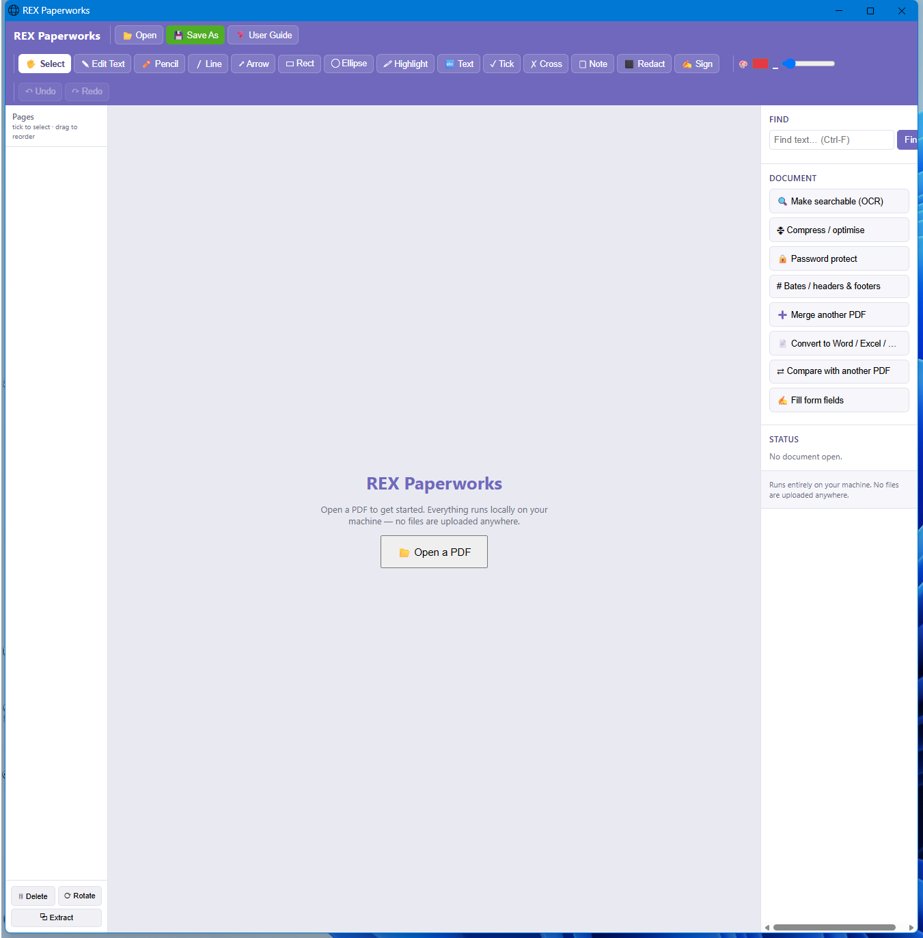
REX Paperworks with no document open, showing the toolbar, markup tools, and side panel.
This edition of the manual (27 September 2026) matches the latest build: REX Paperworks now runs in its own window (no web browser involved), opens several PDFs in tabs, and includes the page-rendering and OCR engines so nothing else needs to be installed.

2. The Window Layout

2.1 Toolbar
Across the top: Open and Save As on the left, followed by every markup tool (Select, Edit Text, Pencil, Line, Arrow, Rectangle, Ellipse, Highlight, Text box, Tick, Cross, Note, Redact, Sign), then colour/line-weight controls for whichever tool is active, and Undo/Redo on the right.
Open, Save and Save As sit at the left of the toolbar, with the name of the open file shown beside them and in the window title. When more than one PDF is open, a row of tabs appears: click a tab to switch documents (each keeps its own page, markups and undo history) and click its × to close it.

2.2 Pages panel (left)
Thumbnails of every page in the open document. Tick pages to select them, then use Delete, Rotate, or Extract at the bottom of the panel. Drag thumbnails to reorder pages.

2.3 Viewer (centre)
The current page is rendered here at the chosen zoom level, with Previous/Next page buttons and a zoom control below it. All markup drawing happens directly on this page.

2.4 Document tools (right)
Find text across the document, and a set of whole-document actions: OCR, Compress, Password protect, Bates/headers & footers, Merge, Convert, Compare, and Fill form fields. A status panel shows the currently open file and page count.

3. Opening and Viewing a PDF
Click Open (or the big “Open a PDF” button in the centre when nothing is open yet) and choose a file. The page renders in the centre panel and thumbnails appear on the left:
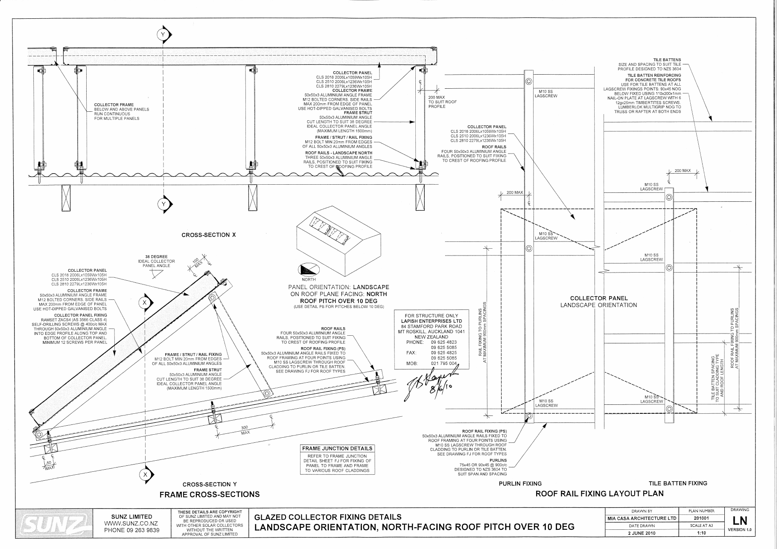
An engineering drawing rendered inside REX Paperworks.
Btw
Use the Previous/Next buttons or click a thumbnail to move between pages, and the zoom controls (or Ctrl and the mouse wheel) to zoom in and out.
Zoom runs from 20% to 1200%; at high zoom the page is re-rendered sharply and you can scroll in both directions. While pages or OCR are loading, the status panel shows a circular progress ring that fills as the work completes.

4. Markup Tools
Select a tool from the toolbar, then click and drag on the page to draw. Colour and line weight can be changed before or after drawing a shape.
- Select — the default tool; click existing annotations to select, move, resize, or delete them.
- Edit Text — best-effort editing of existing text in a digital (non-scanned) PDF; click a word to change it in place.
- Pencil — freehand drawing.
- Line / Arrow — straight lines, with or without an arrowhead.
- Rectangle / Ellipse — shapes, with an optional fill.
- Highlight — a translucent highlighter stroke.
- Text — a text box, with font, size, bold/italic, and colour controls.
- Tick / Cross — quick approval or rejection marks.
- Note — a sticky note comment.
- Redact — permanently blacks out the selected area — the covered content is removed, not just hidden.
- Sign — place a signature image onto the page.
Undo and Redo (top right of the toolbar) step backward and forward through markup changes.
Select tool: click a markup to select it (a dashed outline and a resize handle appear), drag it to move, drag the handle to resize, and press Delete to remove it. Ctrl+C / Ctrl+V copies and pastes a markup. Drag on an empty part of the page to draw a blue selection box: every markup fully inside the box is selected, and the group moves or deletes together.
Text and Note tools open a small in-app dialog for the text (Enter to confirm, Esc to cancel). Notes have two colour pickers: the outline colour is the main colour swatch and the fill colour is the 📝 swatch that appears when the Note tool is active; both are kept in the saved PDF.
Image and Sign tools ask for a picture file, place it at its natural proportions, and show it immediately; it is selected on placement so you can resize it straight away, and you can write text over it with the Text tool.
Redact and Edit Text really remove the original text from the file (not just cover it), even a single word in the middle of a line, so redacted words cannot be recovered by copy-and-paste or search.

5. Document Tools

5.1 Make searchable (OCR)
Runs Optical Character Recognition over scanned pages so their text becomes selectable and findable, without changing how the page looks. Pages that already contain real text are left untouched to preserve their quality. OCR needs the free Tesseract engine installed once on this machine — everything else in REX Paperworks works without it.

5.2 Compress / optimise
Reduces file size, useful before emailing a large scanned document.

5.3 Password protect
Encrypts the PDF with a password of your choice.

5.4 Bates / headers & footers
Stamps sequential Bates numbering, or a custom header/footer, across some or all pages — commonly used for legal and consenting document sets.

5.5 Merge another PDF
Appends another PDF’s pages onto the end of the current document.

5.6 Convert to Word / Excel / …
Converts the current document to Word, Excel, plain text, or a set of images. Table detection is used for the Excel conversion where possible.

5.7 Compare with another PDF
Shows a text and visual difference between the current document and another PDF — useful for checking what changed between two revisions of a drawing or document.

5.8 Fill form fields
Reads any interactive form fields in the PDF, lets you fill them in, and can flatten the result so the values become permanent, non-editable page content.
Ticking Flatten locks the filled values so they cannot be edited in other PDF viewers.

6. Managing Pages
In the Pages panel on the left, tick one or more thumbnails then use:
- Delete — removes the ticked pages from the document.
- Rotate — rotates the ticked pages 90°.
- Extract — saves the ticked pages out as a new, separate PDF.
Pages can also be dragged into a new order directly in the thumbnail list.
Tick several pages and drag any ticked page to move them together; a blue line shows where they will land. Delete, Rotate and Extract act on the ticked pages.

7. Finding Text
Type into the Find box on the right (or press Ctrl-F) and click Find. Matches are listed below the search box — click a result to jump straight to that page.
Every word of a match is highlighted in yellow on the page — on whichever page you navigate to from the results list. Searching for something that is not found clears the previous highlights.

