REX Visio2DXF
User Manual
Converting Visio drawings to AutoCAD DXF
Energy Conscious Design Limited

1. Introduction
REX Visio2DXF converts Microsoft Visio drawings (.vsdx and legacy .vsd) into real, editable AutoCAD DXF geometry — not a flattened picture, but actual lines, arcs, circles, text, and embedded images that open and edit correctly in AutoCAD LT or any other DXF-compatible CAD package. Everything runs locally on your computer; your drawings are never uploaded anywhere.
Both modern .vsdx files and legacy binary .vsd files are supported. Legacy .vsd conversion uses a bundled copy of LibreOffice, installed automatically and silently the first time you install REX Visio2DXF — there is nothing extra to download or set up.
This edition of the manual (27 September 2026) matches the latest build, which carries the REX look used by REX Paperworks and REX Accounts (blue header, green Convert button, the 'Vd' product icon) and corrections found in testing.

2. The Main Window
REX Visio2DXF has a single window with four steps, run top to bottom.
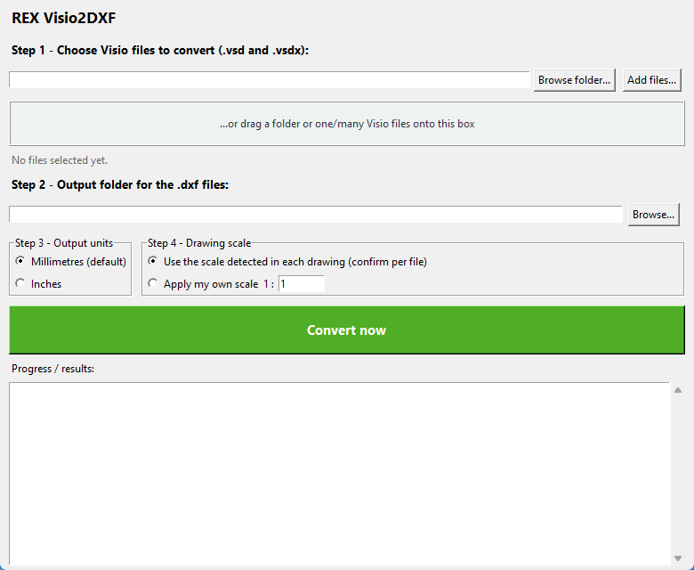
The main window when the app is first opened.

2.1 Step 1 — Choose Visio files
Add drawings to convert in any of three ways:
- “Browse folder…” — selects every .vsd/.vsdx file in a folder at once.
- “Add files…” — pick one or more individual files from a standard file-open dialog.
- Drag and drop — drag a folder, or one or many Visio files, straight onto the box in the middle of the window.
Once files are chosen, the bar above shows what was selected and the file count/type breakdown appears underneath (for example, “1 file(s) selected (1 .vsdx, 0 .vsd)”).
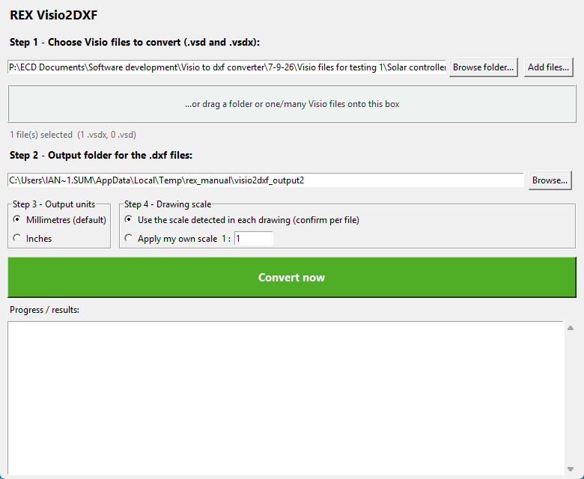
A file selected and ready to convert, with the output folder set.

2.2 Step 2 — Output folder
Choose where the converted .dxf files should be written. If left blank, REX Visio2DXF creates a “converted_dxf” folder next to your source files automatically.

2.3 Step 3 — Output units
Choose whether the DXF geometry is written in millimetres (the default) or inches.

2.4 Step 4 — Drawing scale
REX Visio2DXF reads the drawing scale Visio itself recorded for the page (for example 1:50) and offers to apply it automatically — or you can type in your own scale to apply to every file instead.

3. Converting
Click “Convert now” to start. If a file’s scale needs confirming, a small dialog appears for that file showing the scale REX Visio2DXF detected:
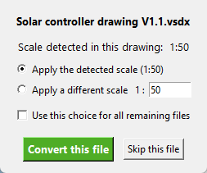
The per-file scale confirmation dialog.

Choose “Apply the detected scale” (recommended in almost all cases) or type a different ratio, tick “Use this choice for all remaining files” to avoid being asked again in a batch, then click “Convert this file”. “Skip this file” leaves that one drawing out of the batch without cancelling the rest.
When conversion finishes, the Progress/results box lists every file converted, how many shapes were converted cleanly, how many embedded images were placed, and how many shapes were flagged for manual review:
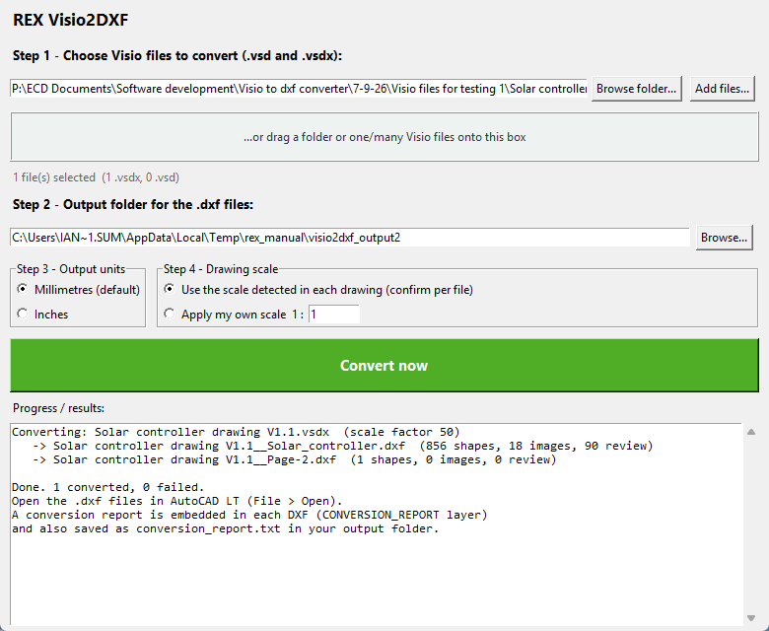
A completed conversion, with the results log.

Each DXF also embeds its own conversion report on a CONVERSION_REPORT layer, and a plain-text copy is saved as conversion_report.txt in the output folder — useful if a drawing needs a closer look after opening it in AutoCAD.
The report block embedded in each DXF sits entirely above the top edge of the drawing on its own CONVERSION_REPORT layer, so it never overlaps your geometry; move or delete it in AutoCAD as you wish.

4. Legacy .vsd files
Older binary .vsd drawings are converted via a bundled copy of LibreOffice rather than being read directly (Visio’s old binary format needs a real Visio-compatible engine to parse reliably). This happens automatically and silently in the background — there is no extra step for a .vsd file compared to a .vsdx file.
If LibreOffice is not present on the computer (for example when REX Visio2DXF was copied rather than installed), a .vsd conversion stops with a clear message; install LibreOffice (free) or save the drawing as .vsdx from Visio. .vsdx files never need LibreOffice.

5. A note on accuracy
REX Visio2DXF aims for the most faithful conversion possible: real arcs and circles (not approximations), correct line colours and weights, embedded images placed at the correct position and rotation, and Visio layers carried through as DXF layers. Any shape that could not be converted with full confidence is placed on a separate REVIEW layer and listed in the results log and conversion report, so it is easy to find and check by hand.

